Cucumber and Selenium are two popular technologies.

Cucumber tool is based on the Behaviour Driven Development framework that **acts as the bridge** between the following :

1. Software Engineer and Business Analyst.
2. Manual Tester and Automation Tester.
3. Manual Tester and Developers.

Cucumber BDD framework also **benefits the client to understand the application code** as it uses Gherkin language which is in Plain Text. Anyone in the organization can understand the behaviour of the software. The syntaxes of Gherkin is in simple text which is readable and understandable.

**Prerequisite for using Cucumber with Selenium**

Before we start Cucumber Selenium integration, we need the following items:

* Selenium jar files:
* Selenium-server-standalone

Can be downloaded at <http://www.seleniumhq.org/download/>

Jar files For Cucumber:

* Cucumber-core
* Cucumber-html
* cobertura code coverage
* Cucumber-java
* Cucumber-junit
* Cucumber-jvm-deps
* Cucumber-reporting
* Hamcrest-core
* Gherkin
* Junit

Can be downloaded at <https://mvnrepository.com/search?q=Cucumber>

You need to search files and download them one by one individually.

**Step 1)** Create Project in eclipse.(STS)

Create Java project with the name “**CucumberTestNG_Demo**” . as shown in the below screenshot.

Java project look like this

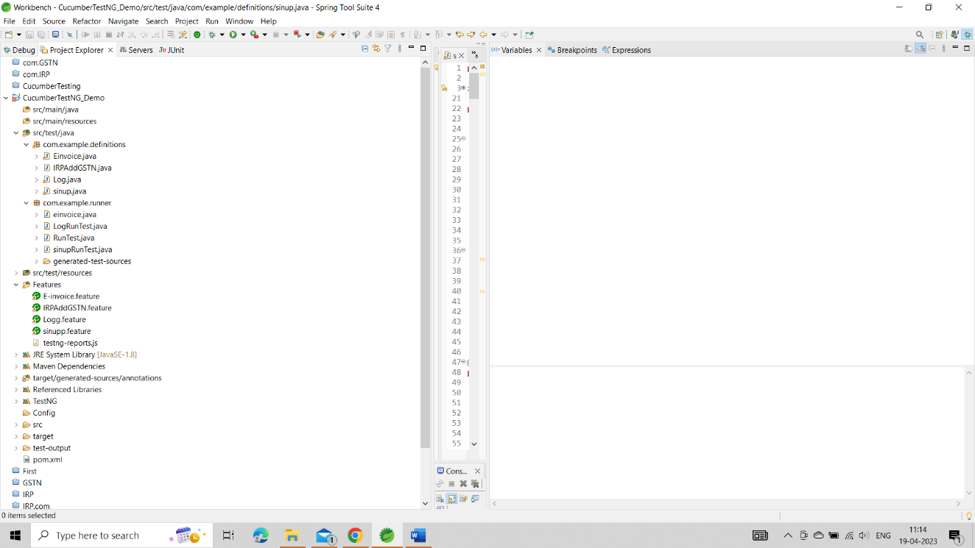

Git site for code we can open and copy paste from this (<https://github.com/ROHIT6059/Automation_IRP.git>)

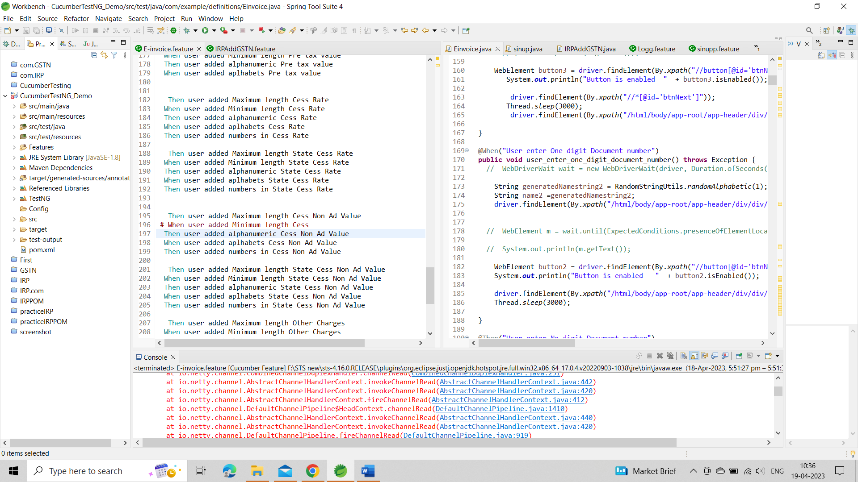

**Step 2)**Adding Jar files in the project.

Right Click on the Project > Select Properties > Go to Java Build Path. Add all the libraries downloaded earlier.

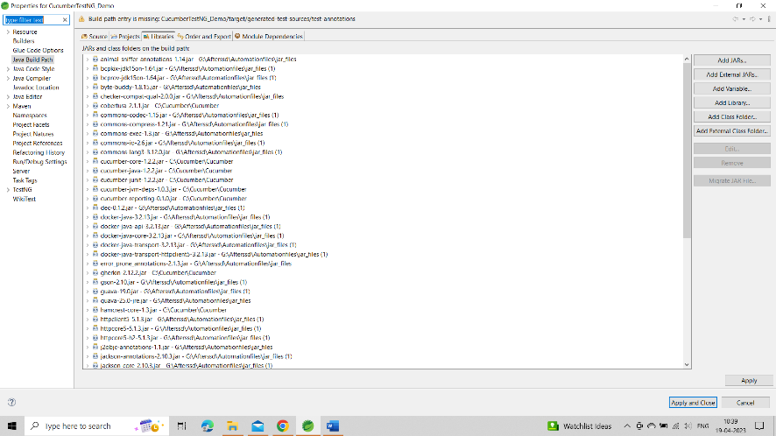

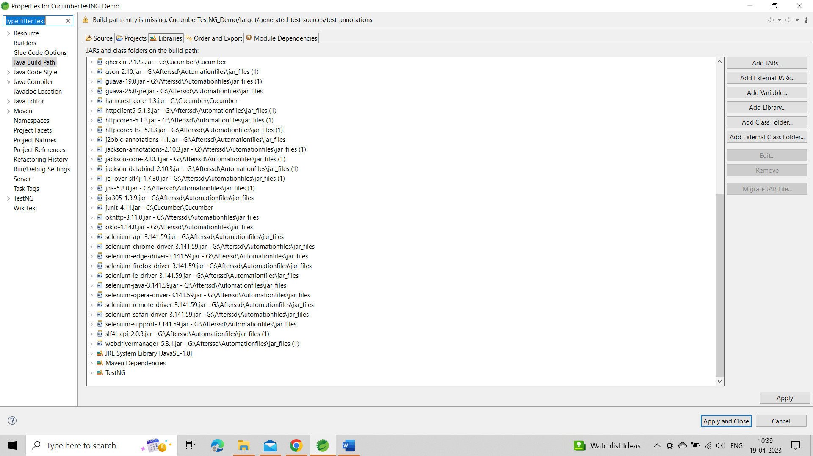

**Step 3)** Creating feature file

For creating feature file first create features folder as shown below screenshot.

Now, create feature file in the ‘Features’ folder with the name of “Logg.feature” – Process is similar to creating a folder

In this screenshot 3 feature file are there. E-invoice,IRPaddGSTN,Logg,signup.

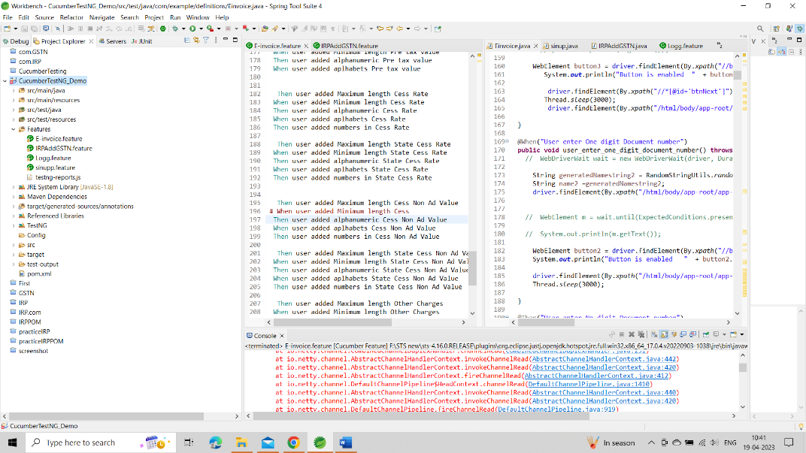

**Note:**You may need to install the Cucumber Eclipse Plugin for this to work.Goto — Helps->Install New Software->copy paste the link <http://cucumber.github.io/cucumber-eclipse/update-site/> and install

**Step 4)**Write scenarios.

Below lines are written in ‘signupp.feature’ file using the Gherkin language as shown below: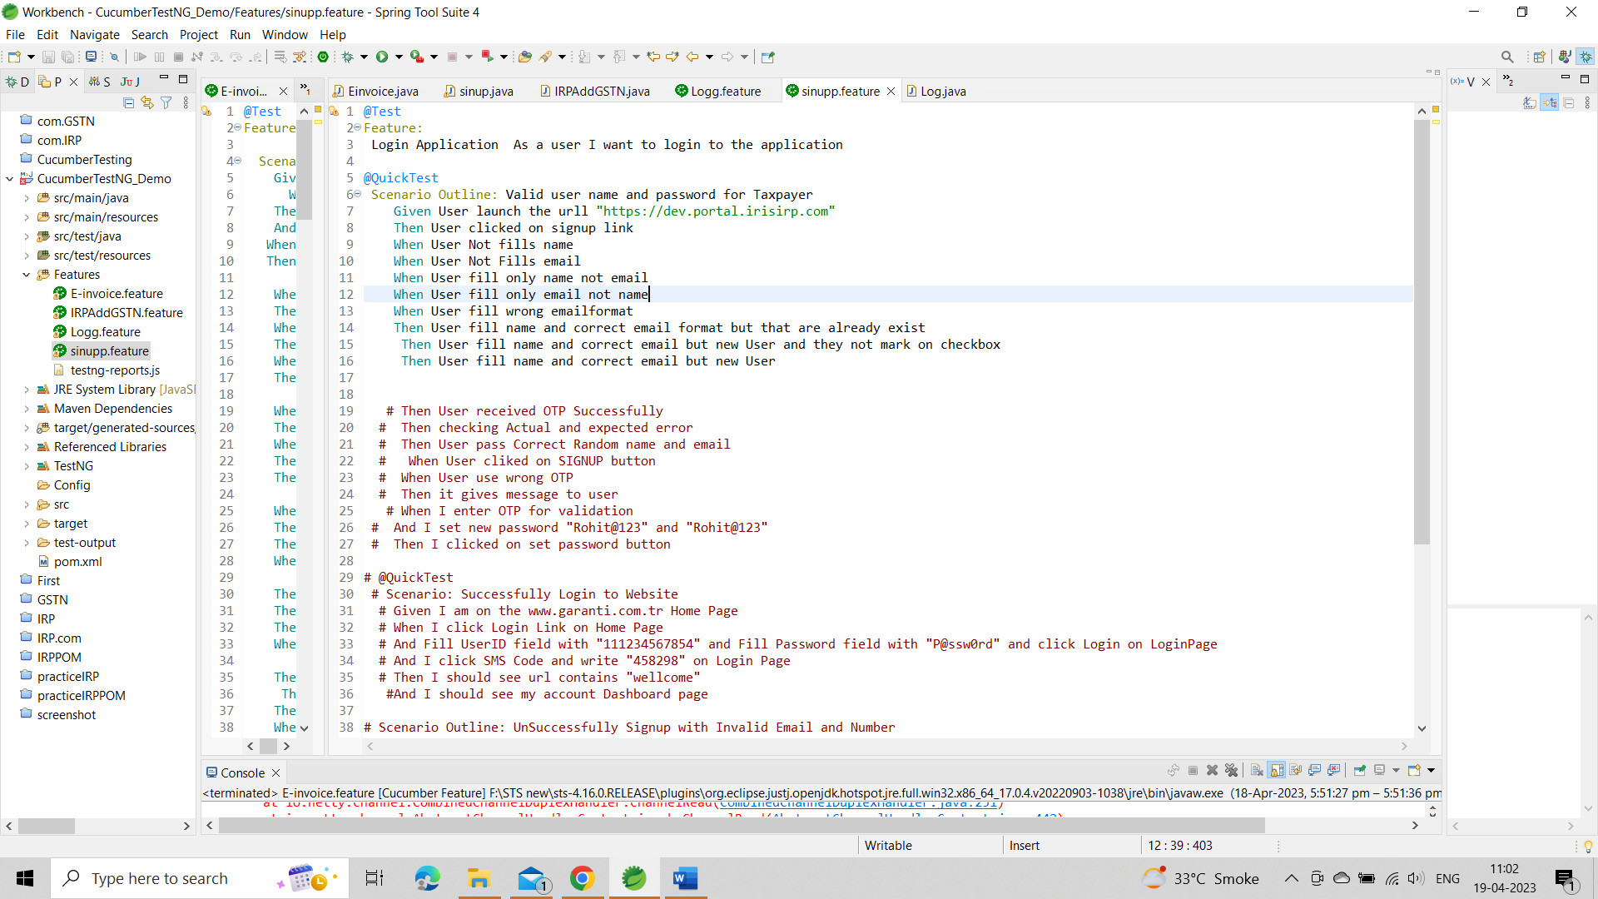

**Code Explanation**

**Line 1)** In this line we write business functionality.

**Line 2)** In this line we write a scenario to test.

**Line 3)** In this line we define the precondition.

**Line 4)** In this line we define the action we need to perform.

**Line 4)** In this line we define the expected outcome or result.

**Step 5)** Writing selenium testrunner script for Selenium Cucumber framework design

Here we create ‘TestRunner’ package and then ‘Runner.java’ class file under it.

Runner.java class file we write logic and code too connected the pages cucumber feature file and selenium (java code).

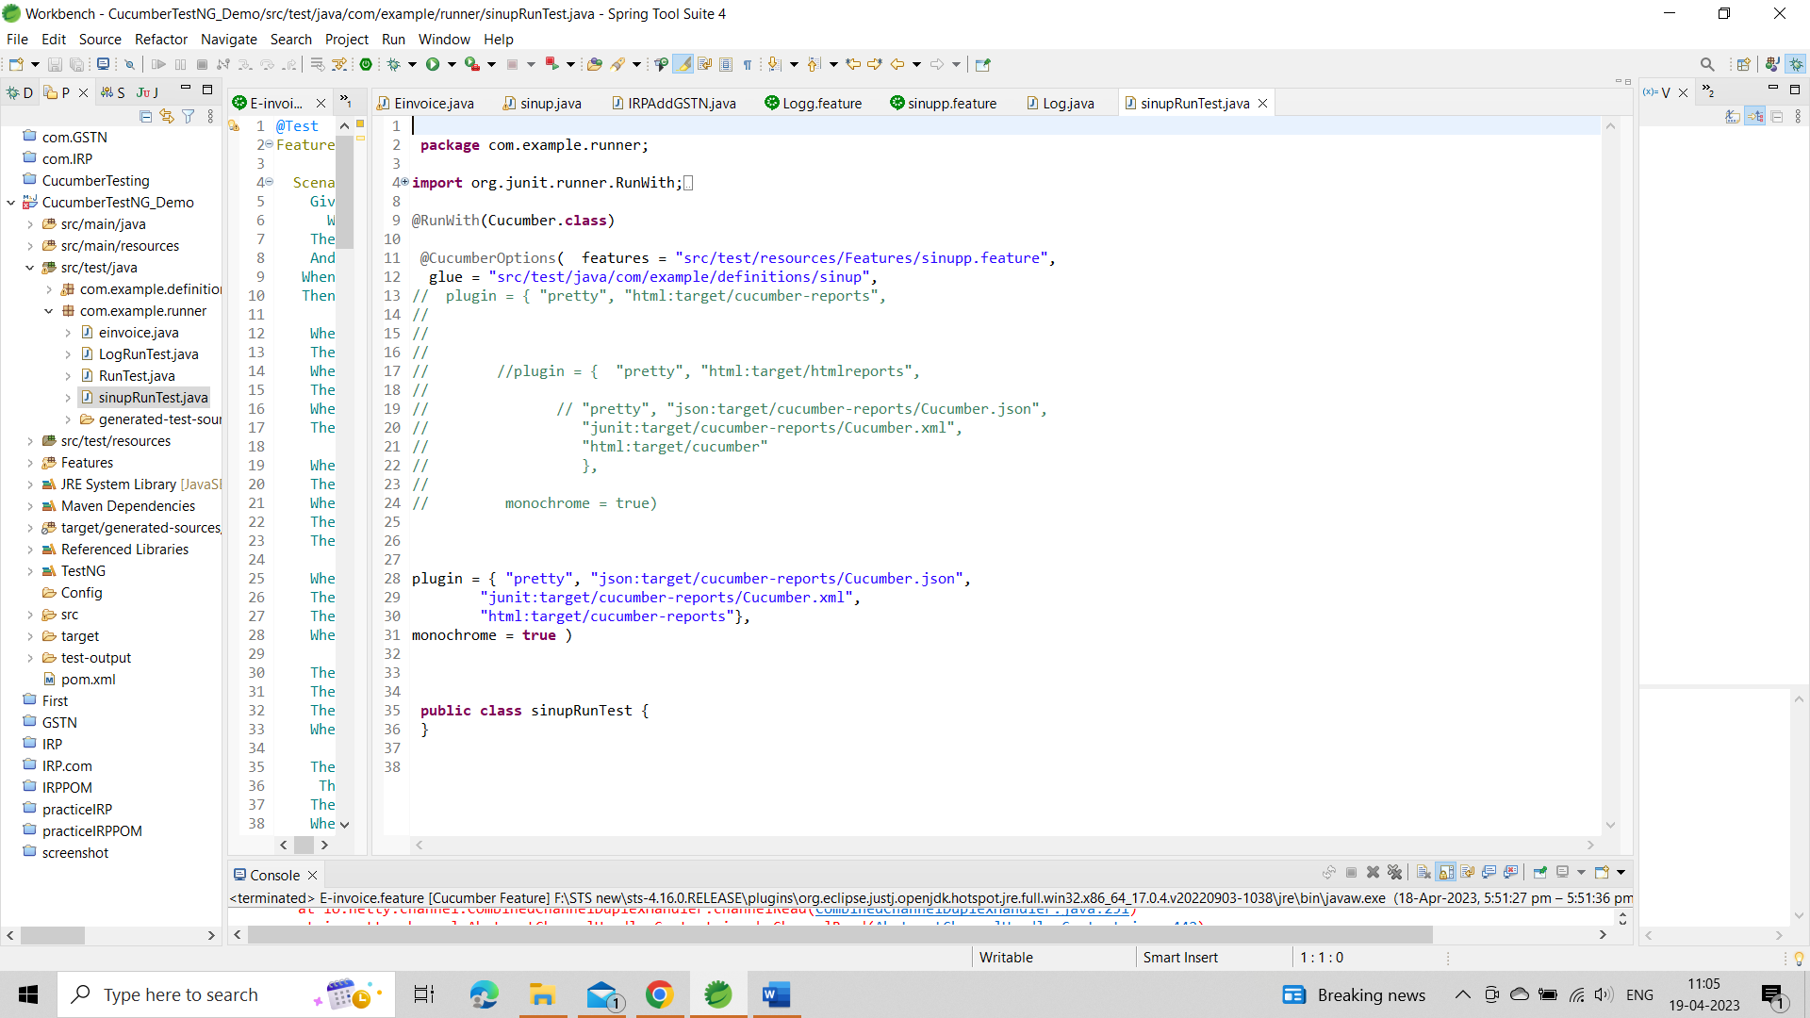

In the above Cucumber Java example code, we run the [cucumber test](https://www.guru99.com/introduction-to-cucumber.html) by using the following annotations:

**@RunWith ()** annotation talks about the test runner class to start executing our tests.

**@CucmberOptions()** annotation is used to set some properties for our cucumber test like feature file, step definition, etc

**Step 6)**Creating Step Definition script.

Now here we create ‘StepDefinition’ package and then ‘signup.java’ script file under it. Here we actually write a selenium script to carry out the test under Cucumber methods.

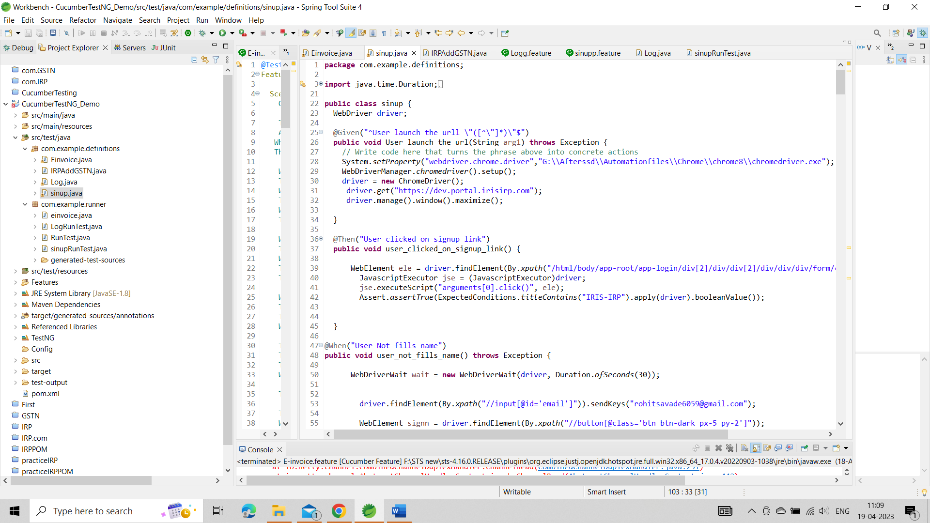

In the above code, the class is created with the name ‘Steps.’ Cucumber annotation is used to map with feature file. Each annotation method is defined:

**@Given** annotation define method to open chrome and launch the application

**@When** annotation define method to enter the username and password

**@Then** annotation define method to reset the credential

Under each method, we are only printing a message.

Cucumber can be integrated with Selenium using following 3 steps

1. Create feature file in which define the feature and scenarios step by step using Gherkin language.
2. Create Testrunner file. In this file, we integrated Cucumber with BDD framework in Selenium. We execute this script.
3. Create Step definition, the actual selenium script defined under this package.

This is the GitHub site I uploaded all the code feature file. Java selenium code, runner for – AddGSTN, Signup, login, and signup

https://github.com/ROHIT6059/Automation_IRP.git